Project Proposal

Problem:

Driving in Victoria can be unpredictable, even if it’s your normal daily commute. One day your commute may take 15 minutes, but on another day it could take 25 minutes along the same route. This is often due to planned construction, which includes road improvement, new developments, and such forth. Local residents at the construction site are often informed in advance, but commuters from other areas are usually not. Applications such as google maps may inform you the day of the delay, but not proactively. While this information might be available online, it is often unintuitive and verbose.

Motivation:

Keeping drivers informed on construction in the Greater Victoria district is crucial to reduce traffic and road delays. Designing a system to inform drivers of construction will help mitigate traffic. Traffic is more than just an inconvenience, it often leads to frustration among drivers. Frustrated drivers have a stronger tendency to engage in unsafe driving behaviours and practices. Tailgating and speeding are among those unsafe behaviours/practices which leads to a greater likelihood of an accident. This is a major reason why keeping drivers informed to reduce traffic can be beneficial to everyone on the road.

Solution:

One of the solutions we came up with is to design a website capable of providing information to its users during or prior to construction, as well as in a more efficient manner. The website will collect data from the "Current Construction & Major Projects" section on victoria.ca to determine both the planned and ongoing road construction projects, and operates through a subscription service, where subscribers can choose how they wish to be notified, whether it's through email or text messages. Subscribers will also be able to input routes they frequently use, which the website will match with roads affected by current and future projects, then notify them via their preferred method should any conflict occur. This approach where drivers are provided with information tailored to their needs is an essential part of Advanced Traveler Information Systems (ATIS)1, which emphasizes the importance of providing information while taking traveler behaviors into consideration. Unlike existing apps that provide only real-time updates, which studies have shown its limitation especially under heavy traffic2, our tool focuses on anticipatory guidance to help commuters plan ahead.

In addition to personalized reminders, the platform will feature an interactive map interface that clearly displays historical, current, and upcoming construction areas—allowing users to quickly understand disruptions across the Greater Victoria area. Each project will be color-coded according to its status (planned, in progress or completed), and will provide links to official documents for users to further understand. More importantly, the platform will also provide a built-in feedback channel for residents to submit concerns or suggestions directly to the appropriate government departments. By simplifying the communication process and improving transparency, the system can not only provide information to the public, but also encourage citizens to actively participate and help the government respond to construction-related issues more effectively.

By organizing fragmented government information and aligning it with the daily needs of drivers, our system aims to foster a more transparent relationship between citizens and municipal infrastructure planning—ultimately contributing to a smoother transportation experience.

Sketch Examples:

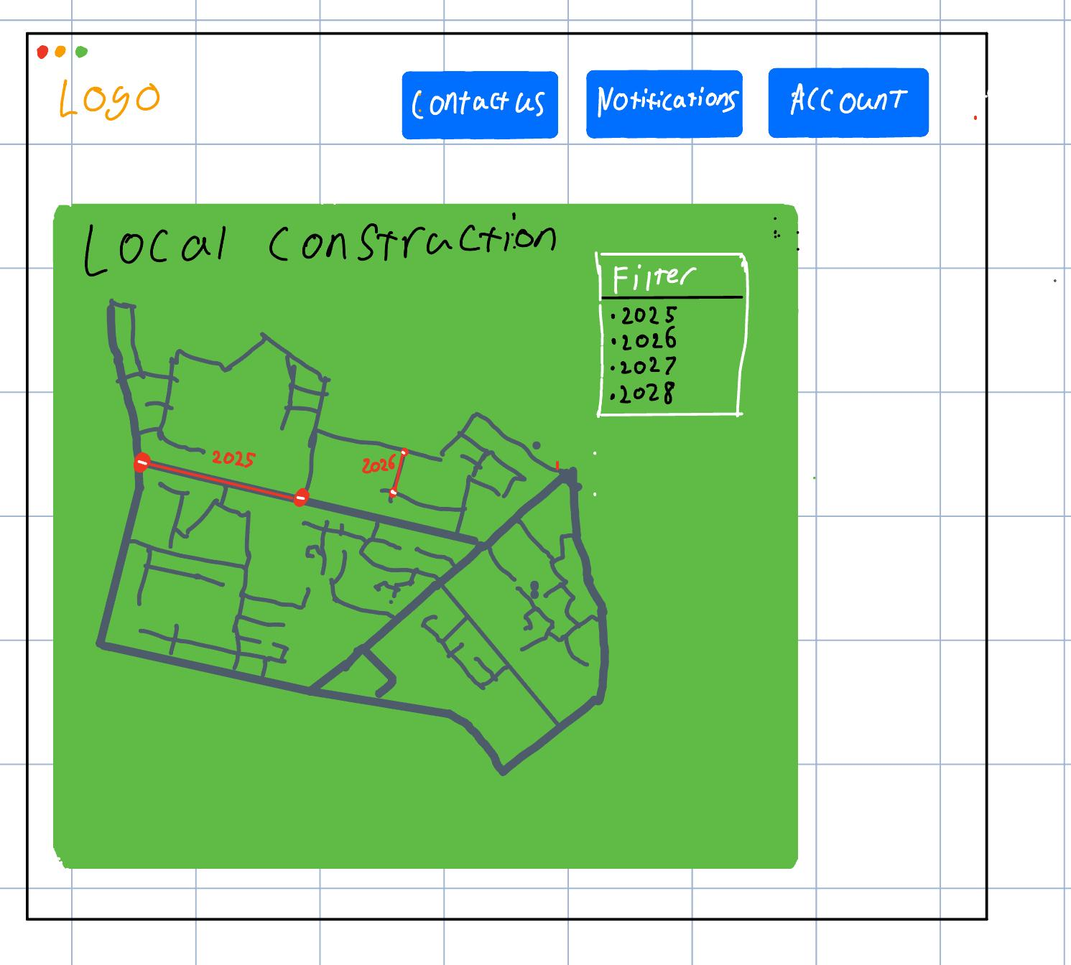

Figure 1: sketch #1(website main page)

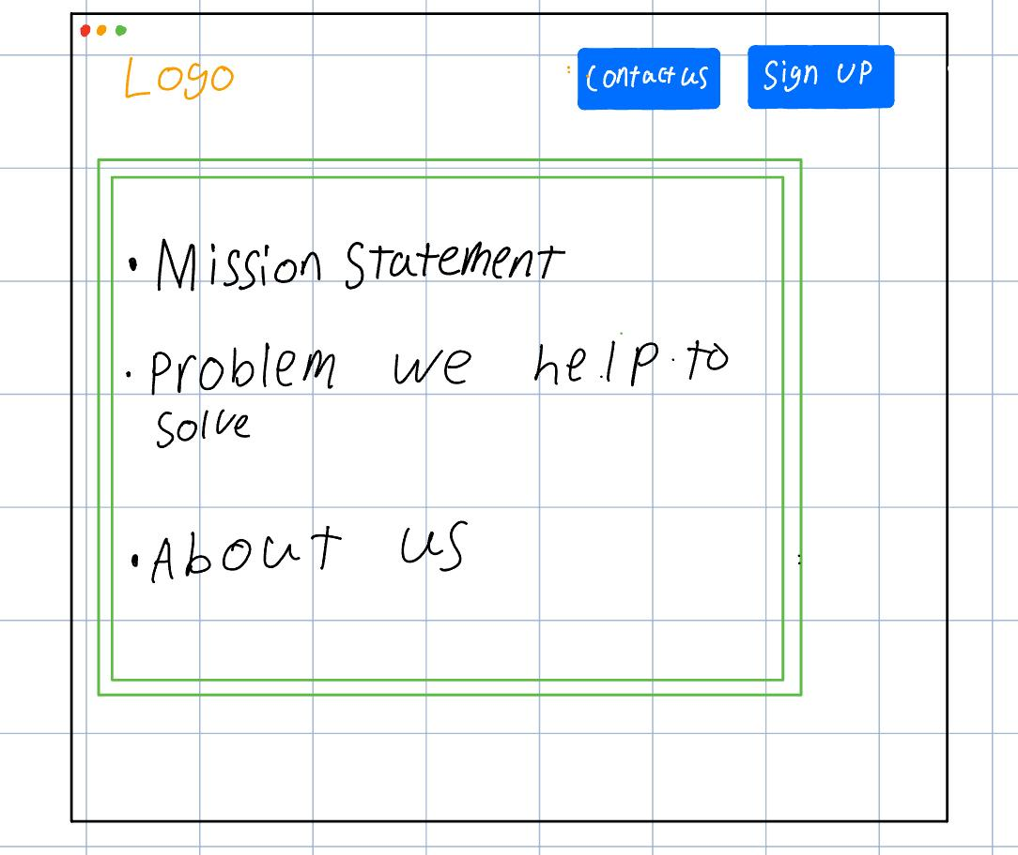

Figure 2: sketch #2(website landing screen)



Figure 3: sketch #3(text message notification)

References:

1. Nora Reinolsmann, Wael Alhajyaseen, Tom Brijs, Ali Pirdavani, Veerle Ross, Qinaat Hussain, Kris Brijs, Delay or travel time information? The impact of advanced traveler information systems on drivers’ behavior before freeway work zones, Transportation Research Part F: Traffic Psychology and Behaviour, Volume 87, 2022, Pages 454-476, ISSN 1369-8478, <https://doi.org/10.1016/j.trf.2022.05.001>. (<https://www.sciencedirect.com/science/article/pii/S1369847822000882>)
2. Francesc Soriguera, On the value of highway travel time information systems, Transportation Research Part A: Policy and Practice, Volume 70, 2014, Pages 294-310, ISSN 0965-8564, <https://doi.org/10.1016/j.tra.2014.10.005>. (<https://www.sciencedirect.com/science/article/pii/S0965856414002390>)